DATA SCIENCE
PROJECT

Data Exploration And Insights:

Topic: Netflix Dataset EDA

SUBMITTED BY:
SHAGUN RATAN
(24201010140)

SUBMITTED TO:
MR. SAMARTH AMRUTE
(IBM FACULTY, CSE)

COURSE: BCA IBM
SEMESTER: 3rd

UNITED UNIVERSITY

- Importing Netflix Dataset:

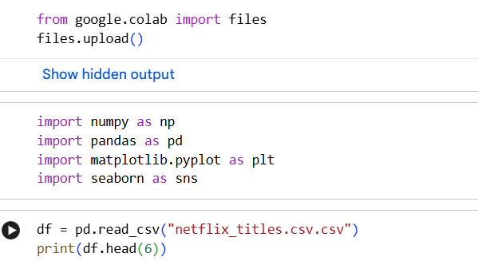

- Data Cleaning and Preparation:
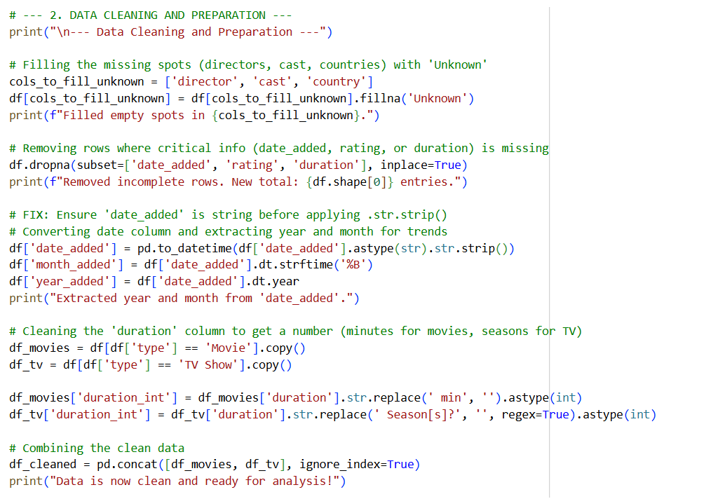

- Defining Netflix color theme:

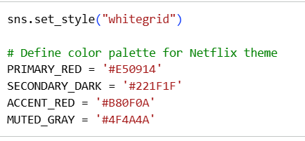

- 12 Insights derived from Netflix Dataset:

- INSIGHT 1: Movie vs. TV Show Ratio

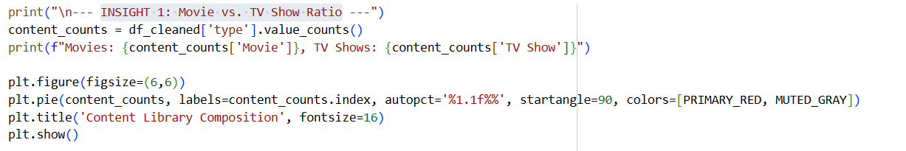

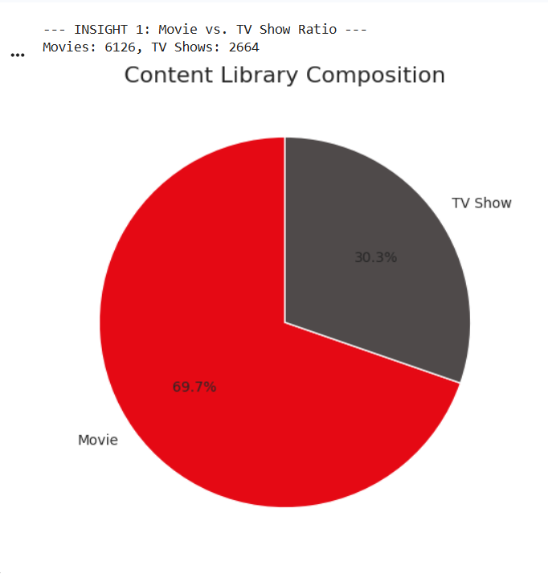
Explanation:
- First, I counted how many entries are 'Movie' and how many are 'TV Show' in the type column of my df_cleaned DataFrame.
- I printed those counts so I could see the exact numbers right away.
- Finally, I made a pie chart

- INSIGHT 2: Top Contributing Countries

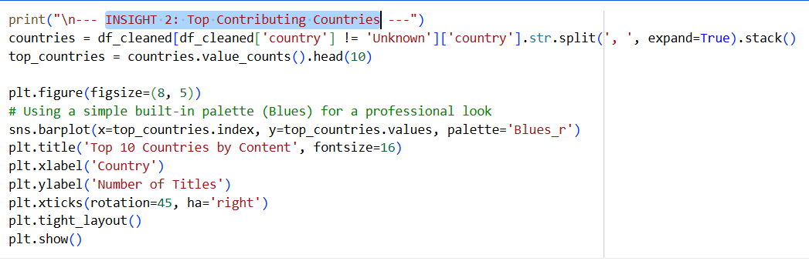

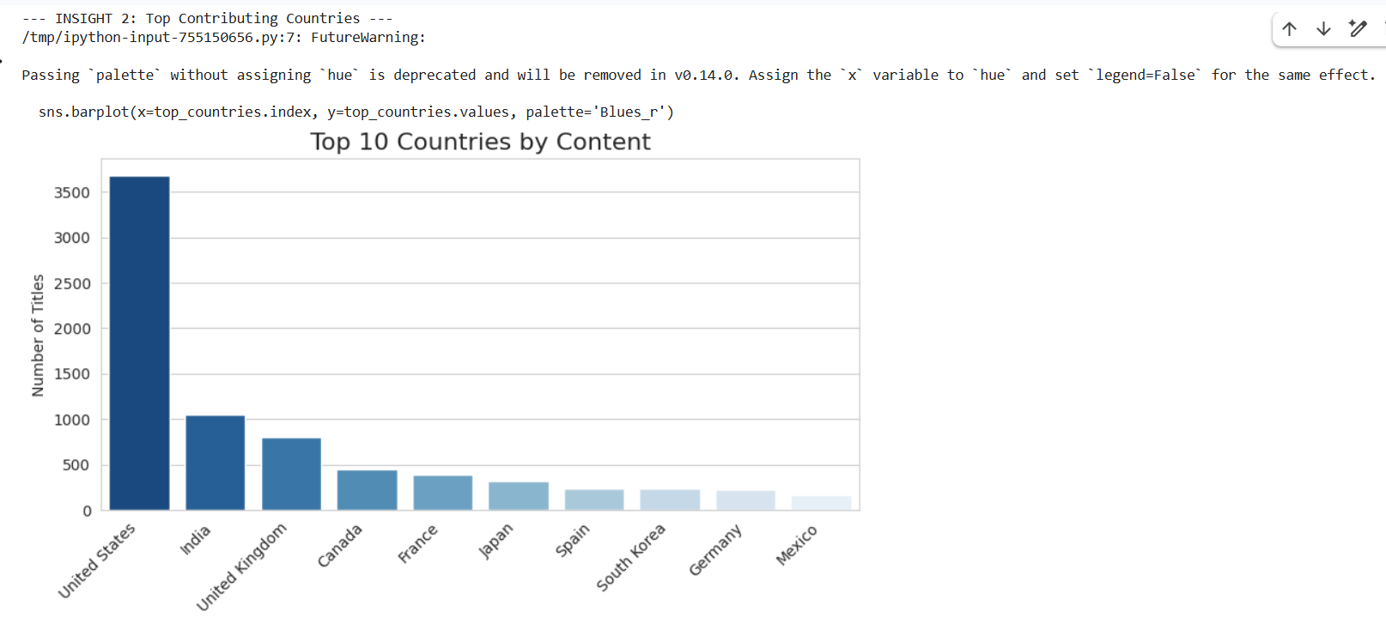

Explanation:
- I first cleaned the data by removing any titles where the country of origin was listed as 'Unknown'.
- Next, I had to separate all countries listed for a single title (since a show can have multiple production countries) and make a big list of every country mentioned.
- Then, I counted which countries appeared the most and picked the top 10.
- Finally, I made a bar chart using Seaborn to visualize these top 10 contributors, making sure to rotate the country names on the bottom so they're easy to read.
- This gives me the top 10 content sources for the service.

- INSIGHT 3: Annual Content Addition Trend

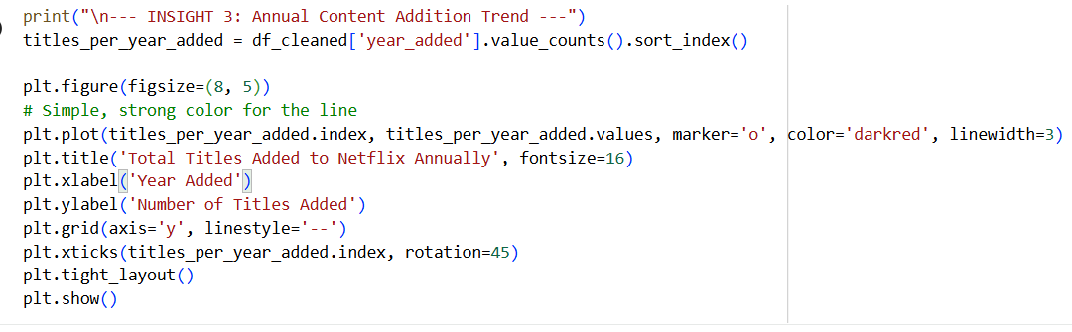

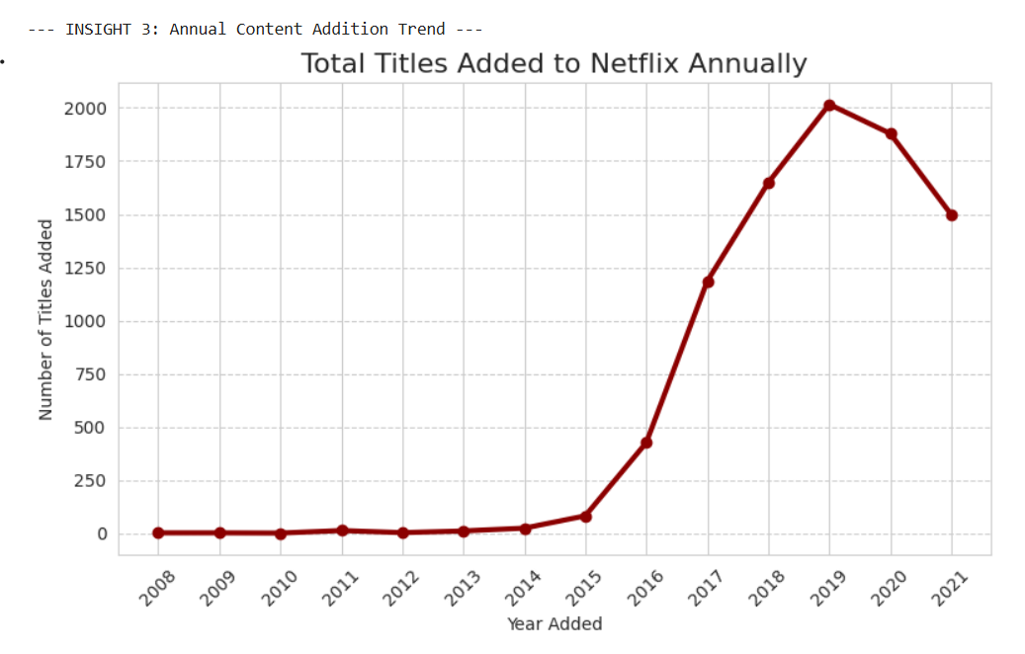

Explanation:
- I calculated how many movies and TV shows were added to the platform each year using the year_added column in my df_cleaned DataFrame.
- I sorted these counts by year to maintain the correct chronological order.
- Finally, I generated a line plot

- INSIGHT 4: Top Directors

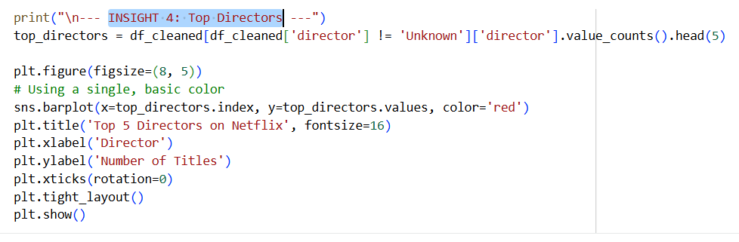

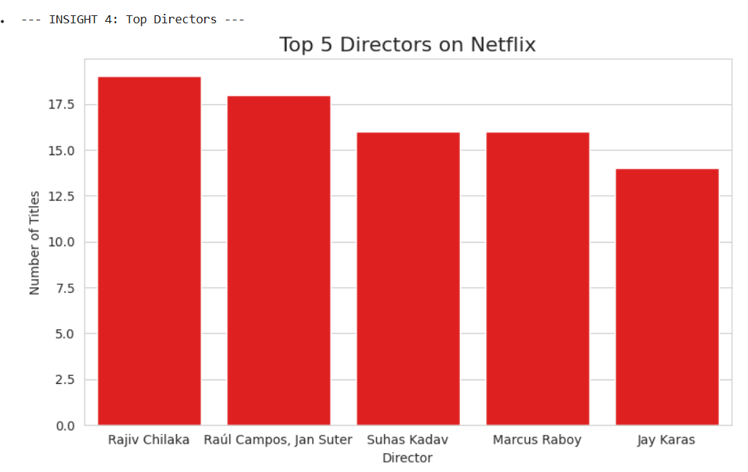

Explanation:
- First, I cleaned the data by filtering out any titles where the director was listed as 'Unknown'.
- From the remaining data, I counted the number of titles directed by each person.
- I then selected only the top 5 directors based on those counts.
- Finally, I created a bar chart using Seaborn to display these top 5 directors and the number of titles they directed, using a simple red color and ensuring the plot layout was neat and compact.
- This quickly shows me who the most prolific directors are on the service.

- INSIGHT 5: Audience Ratings Distribution
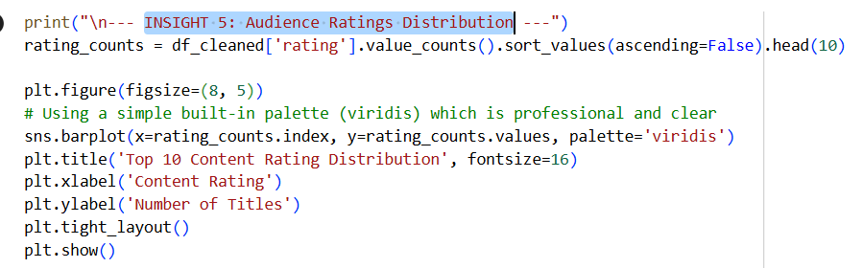

Explanation:
- I counted the frequency of every unique rating (like 'TV-MA' or 'PG-13') in the rating column.
- I selected only the top 10 most common ones to focus on the main content buckets.
- Then, I generated a colorful bar chart using Seaborn to clearly display how much content falls under each major rating.

- INSIGHT 6: Average Movie Duration
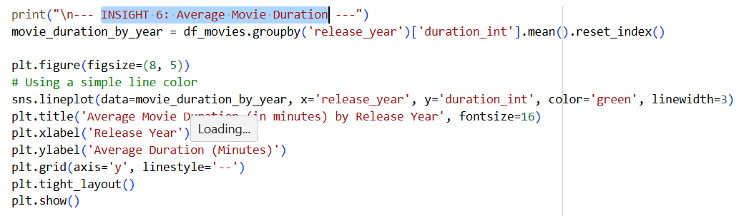

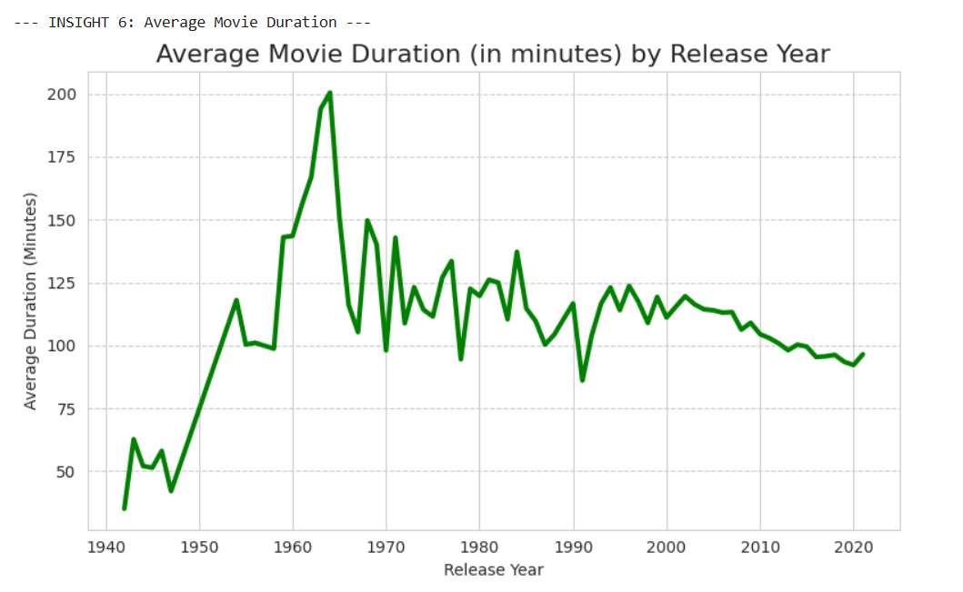

Explanation:
- I first filtered my data to only include movies (df_movies).
- Next, I grouped the movies by the release_year and calculated the average duration in minutes (duration_int) for all movies released in that year.
- Finally, I made a line plot using Seaborn to visualize this average length over time, using a thick green line and a grid to make the trend clear.
This shows me if movies have been getting longer or shorter over the years.

- INSIGHT 7: Top Genres

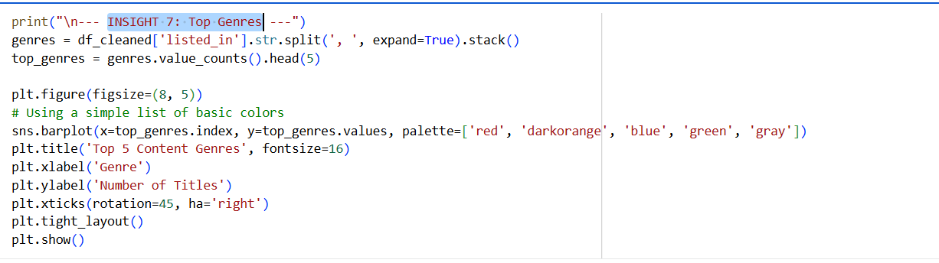

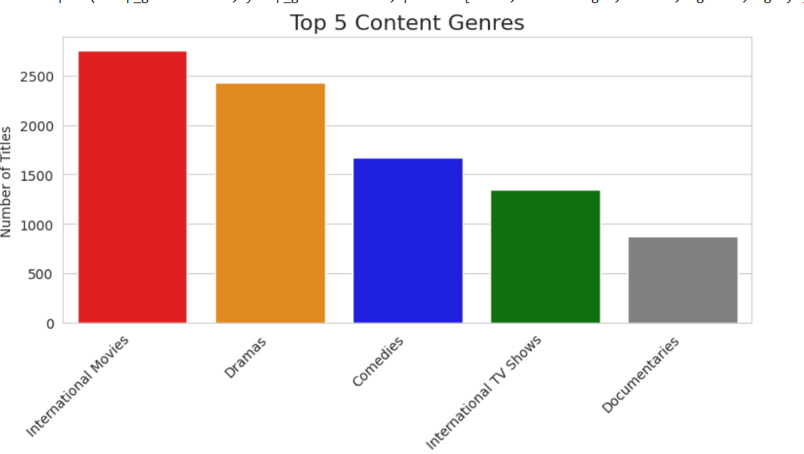
Explanation:
- I took the listed_in column, which contains all the genres, and separated every single genre listed for every title, creating one massive list of all genres.
- I counted how many times each genre appeared and picked out the top 5 most frequent ones.
- Finally, I created a bar chart using Seaborn to display these top 5 genres, using a simple set of colors and rotating the labels on the x-axis so I could read the genre names easily.
This gives me a clear view of the content catalogue's core genres.

- INSIGHT 8: Rating Breakdown (Movies vs. TV)

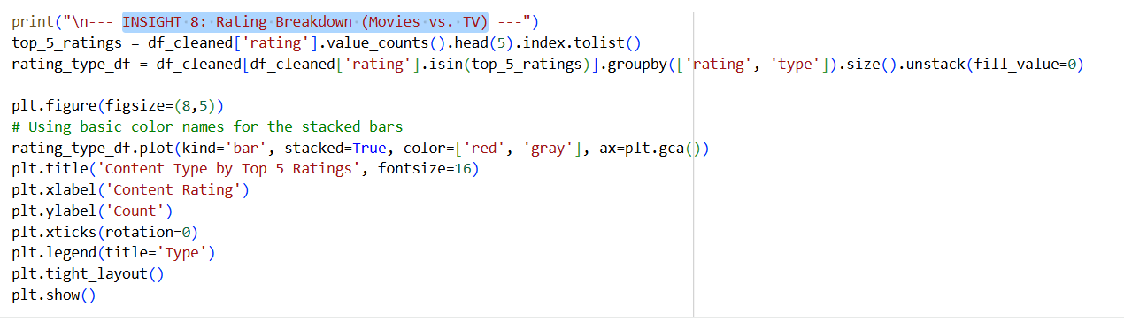

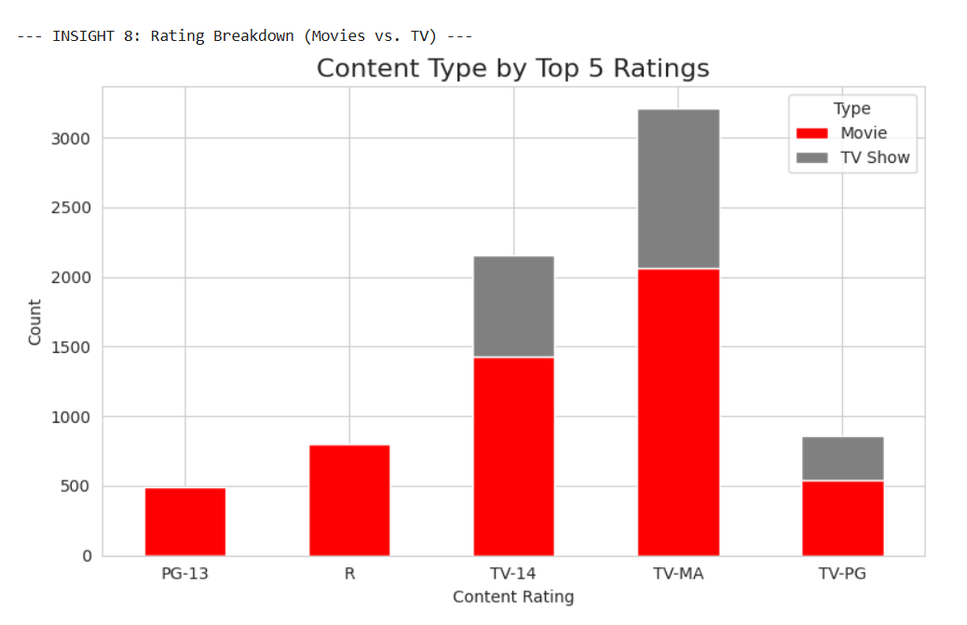

Explanation:
- First, I identified the top 5 most common audience ratings in the entire dataset.
- I then filtered the data to only include titles that have one of those top 5 ratings.
- Next, I grouped the titles by both the rating and whether they were a 'Movie' or 'TV Show', counting the titles for each group.
- Finally, I created a stacked bar chart

- INSIGHT 9: Content Age at Addition

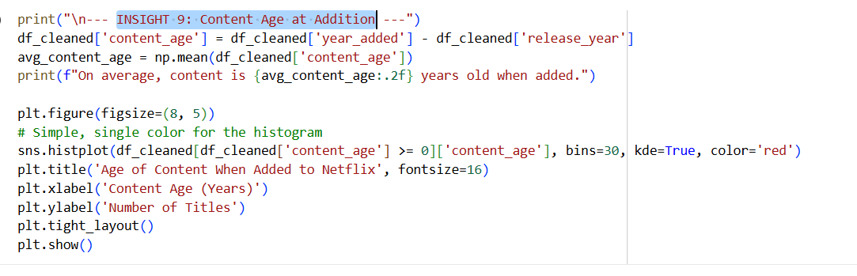

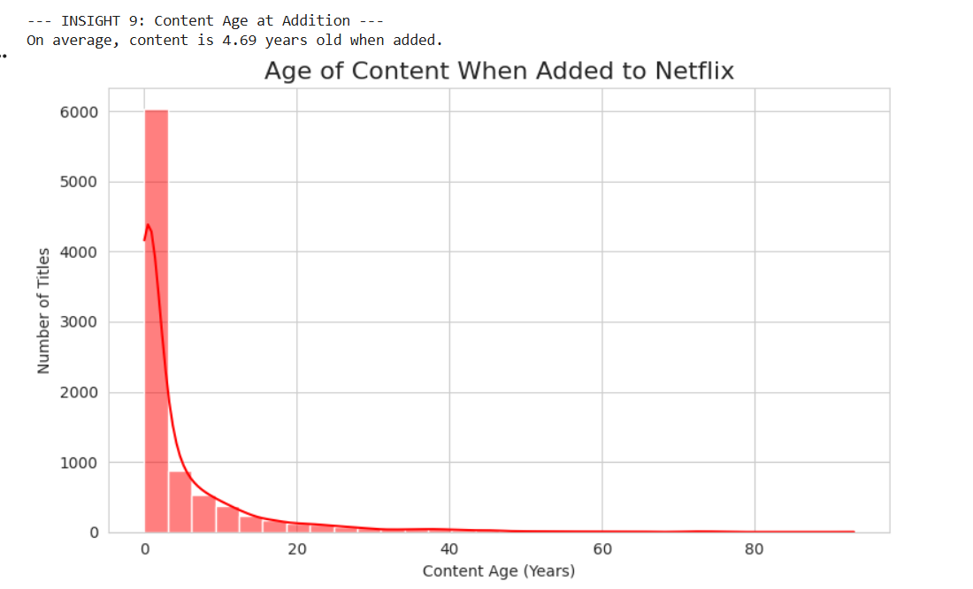

Explanation:
- I created a new column called content_age by subtracting the release year from the year it was added to Netflix. This tells me the content's age in years when it was acquired.
- I calculated and printed the average content_age across the entire dataset.
- Finally, I made a histogram using Seaborn to visually display the full distribution of these ages. I included a smoothed curve (KDE) over the bars for a clear view of the central tendency, using a red color.
  - This shows me the typical lag between a title's release and its arrival on the platform.

- INSIGHT 10: Top Actors/Cast

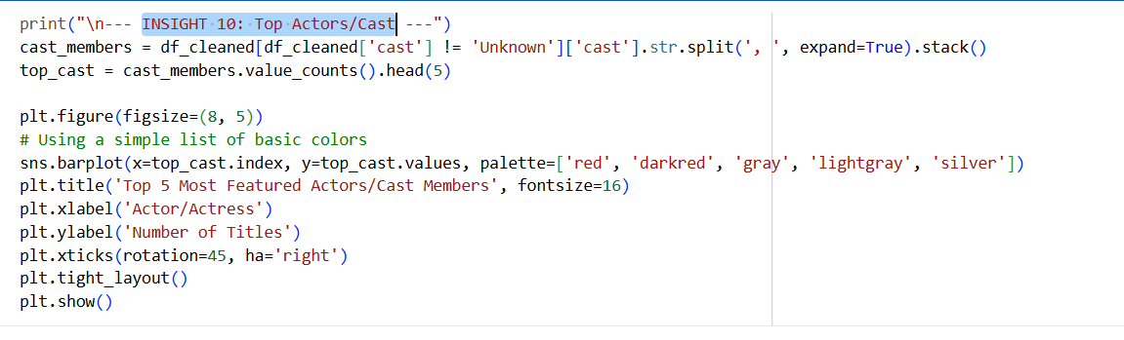

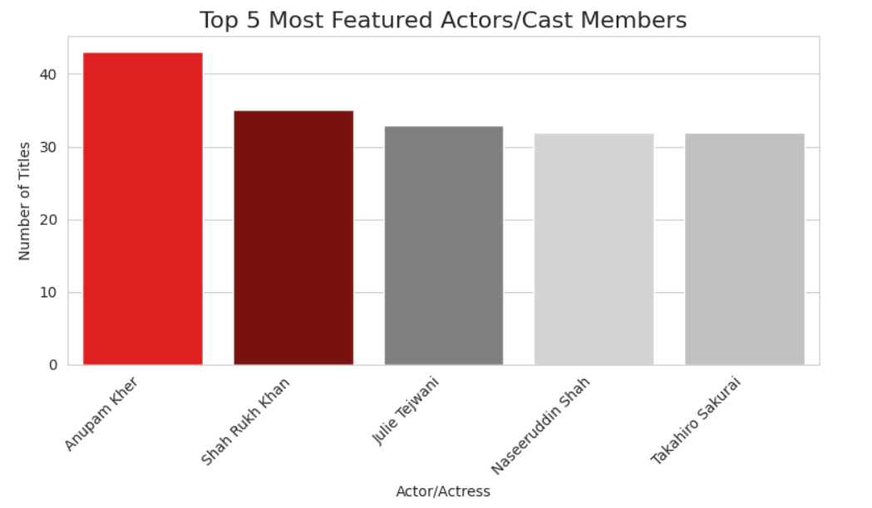

Explanation:
- I first cleaned the data by removing any titles where the 'cast' was listed as 'Unknown'.
- Then, for titles with multiple cast members, I separated every name from the 'cast' column to create one large list of all cast appearances.
- I counted how many times each actor appeared and selected the top 5 most frequent ones.
- Finally, I made a bar chart using Seaborn to display these top 5, using a few simple colors and rotating their names on the x-axis for easy reading.
This tells me which actors have the most titles in the catalogue.

- INSIGHT 11: US vs. India Growth Trend

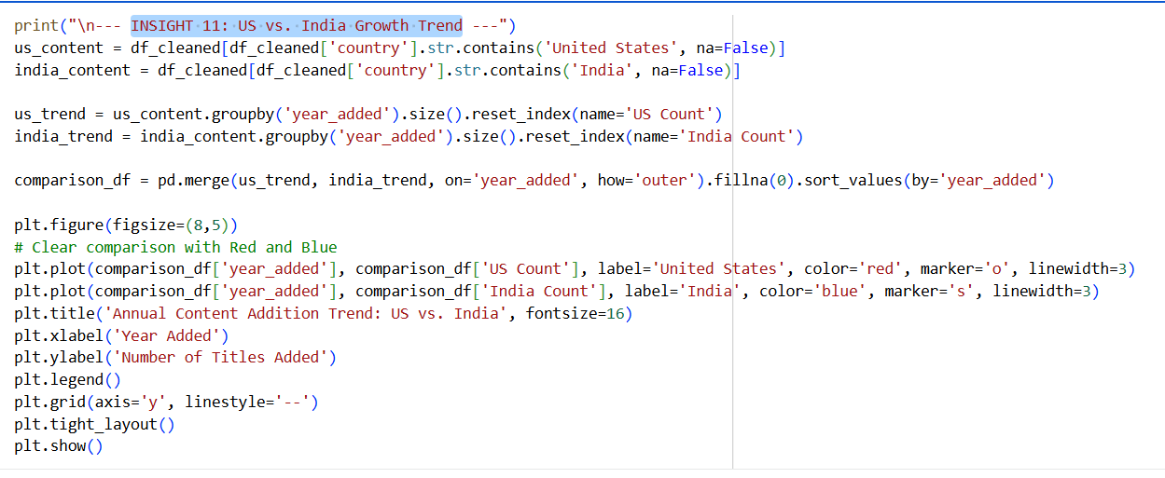

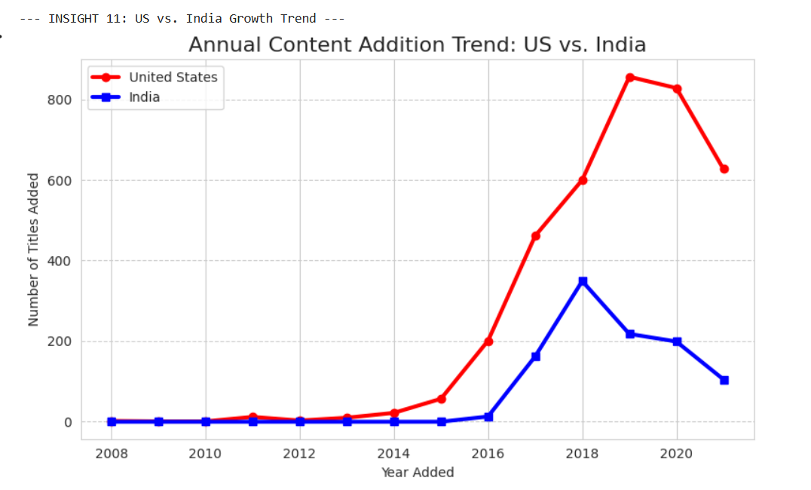
Explanation:
- I separated titles made in the 'United States' and 'India'.
- I counted yearly additions for both countries and combined the trends.
- I made a line plot to visualize the two trends side-by-side (US in red, India in blue).
This directly shows how the production growth rate compares between these two regions.

- INSIGHT 12: Best Month for Releases

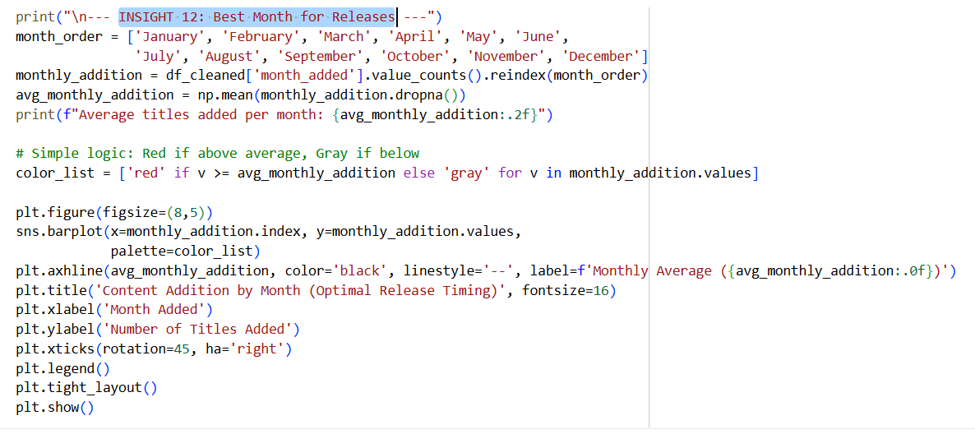

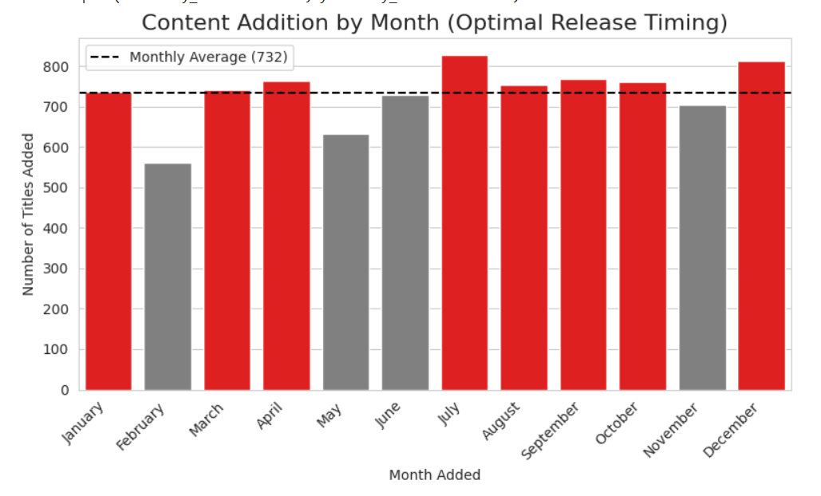

Explanation:
- I counted the total number of titles added for each month and made sure they were in the right chronological order.
- I calculated and printed the overall average number of titles added per month.
- I made a bar chart to show the monthly additions. I used red for months that were above or equal to the average and gray for months below it.
- I added a dashed line for the average to make the comparison really clear.
This shows me when the platform typically releases the most content.

